MEMO

From: Richard Rennehan, 0413101, IT Data Analytics
To: Bill Cunningham
Date: November 29, 2018

SUBJECT: DBAS3018 ASSIGNMENT 4

Statement of Requirement

The purpose of this memo is to share a function, procedure and trigger that manages the shipment_line table of Clearwater Traders with one easy step. The goal of this memo is to display my knowledge of creating functions, procedures, and triggers.

The function will be able to calculate the total value of any inventory ID passed to it. The function multiplies the quantity on hand by the price and returns the result.

The procedure will be able to automatically update a desired shipment with today’s date once the shipment has been received. It is as simple as executing the function with the inventory ID and line number. The procedure then connects to the function to display the price and quantity on hand of the inventory.

The trigger will update the inventory table’s quantity on hand for any shipment that has arrived. After a successful arrival, it will call the procedure using the ID of the inventory that arrived.

To manage the inventory and shipment of the database, all that needs to be done is to execute the procedure and pass in the shipment number and inventory number as parameters.

Existing Materials

The database used is the official Clearwater Traders database. The database was sourced from a textbook called Database Systems: Design, Implementation, and Management. It is written by Carlos Coronel and Steven Morris. It is the 12e edition.

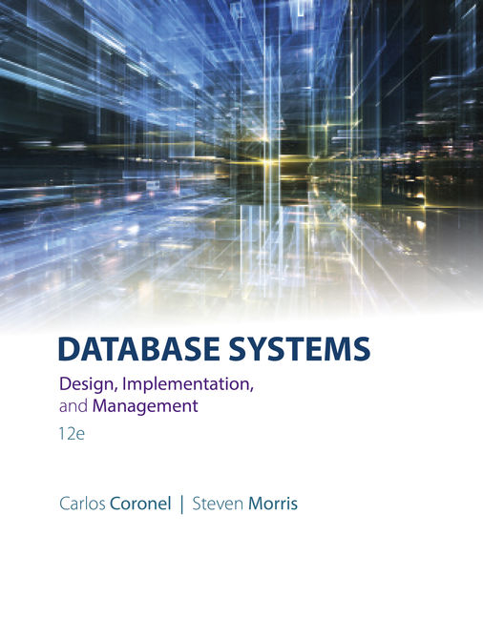
Figure 1: Textbook cover for the source of the data

SQL Code

Ensure to run each in the order given below.

Function for Calculating Value of Item

CREATE OR REPLACE FUNCTION FUNC_VALUE (F_INV_ID IN NUMBER)
RETURN VARCHAR
IS
F_TOTAL_VALUE NUMBER;
BEGIN
SELECT (INV_PRICE * INV_QOH) INTO F_TOTAL_VALUE
FROM INVENTORY
WHERE INVENTORY.INV_ID = F_INV_ID;
RETURN F_TOTAL_VALUE;
END;

Procedure for Updating Shipment Arrival

CREATE OR REPLACE PROCEDURE PRC_SHIPMENT_ARRIVAL
(P_SHIP_ID in NUMBER, P_INV_ID in NUMBER)
AS
P_NEW_QOH INVENTORY.INV_QOH%TYPE;
P_DATE SHIPMENT_LINE.SL_DATE_RECEIVED%TYPE;
BEGIN
SELECT SL_DATE_RECEIVED INTO P_DATE
FROM SHIPMENT_LINE
WHERE SHIP_ID = P_SHIP_ID AND INV_ID = P_INV_ID;

IF P_DATE IS NULL THEN
UPDATE SHIPMENT_LINE
SET SL_DATE_RECEIVED = SYSDATE
WHERE SHIP_ID = P_SHIP_ID AND INV_ID = P_INV_ID;

SELECT INV_QOH INTO P_NEW_QOH
FROM INVENTORY
WHERE INV_ID = P_INV_ID;

DBMS_OUTPUT.PUT_LINE('Inventory has been updated. Inventory ' || P_INV_ID ||
' now has ' || P_NEW_QOH || ' units for a total value of $' ||
FUNC_VALUE(P_INV_ID));
ELSE
DBMS_OUTPUT.PUT_LINE('The shipment has already arrived on ' || P_DATE ||
'. Inventory QOH has not been updated');
END IF;
EXCEPTION
WHEN NO_DATA_FOUND THEN
DBMS_OUTPUT.PUT_LINE('The requested ship ID and inventory ID do not exist');
END;

Trigger Statement for updating Quantity on Hand (QOH)

CREATE OR REPLACE TRIGGER TRIG_QOH_UPDATE
AFTER UPDATE ON SHIPMENT_LINE
FOR EACH ROW
BEGIN
CASE
WHEN UPDATING('SL_DATE_RECEIVED') THEN
UPDATE INVENTORY
SET INV_QOH = INV_QOH + :OLD.SL_QUANTITY
WHERE INV_ID = :OLD.INV_ID;
END CASE;
END;

Testing Plan

Iteration Number | Test | Expected Result | Actual Result | Solutions
1 | Test function with:  SELECT FUNC_VALUE(2)  FROM DUAL; | The function returns the total value of items from the Inventory table with Inventory ID 2 | It displays the result of 3119.88.  259.99 multiplied by 12 is exactly that. | No problems encountered
2 | Test Procedure and trigger with:  EXECUTE PRC_SHIPMENT_ARRIVAL (2,2); | Procedure alters the correct record with today’s date.  This automatically runs the trigger which updates the inventory QOH  Procedure prints a message stating the new number of units. Connects successfully to function | The shipment line table’s SHIP_ID 2 with INV_ID 2 was correctly updated to match today’s date of December 7, 2018.  The shipment had a quantity of 25. The QOH was successfully updated from 12 to 37. Thirty-seven multiplied by 259.99 gives the correct value of 9619.63  Statement processed.  Inventory has been updated. Inventory 2 now has 37 units for a total value of $9619.63 | No problems encountered but will implement a quick fix preventing a shipment that has already arrived from updating QOH again. Also, will add an exception block if there is no matching inventory and ship ID
3 | Test Procedure error handling with:  EXECUTE PRC_SHIPMENT_ARRIVAL(5,20); | The database prints a simple message stating the combination does not exist. | Statement processed.  The requested ship ID and inventory ID do not exist | No problems encountered
4 | Test shipment that has already arrived with:  EXECUTE PRC_SHIPMENT_ARRIVAL(1,1); | Procedure prints date it has arrived. Skips over the trigger and function call. | Statement processed.  The shipment has already arrived on 10-SEP-06. Inventory QOH has not been updated | No problems encountered.

Snapshots
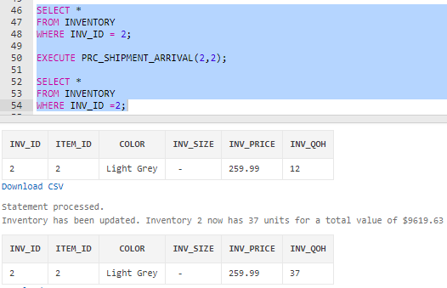
Figure 2: Proof that the trigger is ran successfully after the date is updated in the procedure
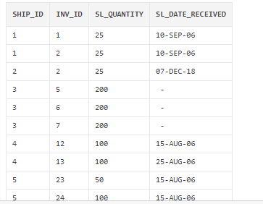
Figure 3: After running the procedure, ship 2 with inventory 2 gets updated to today’s date

